



| Business Plan Template |
| --- |



You can edit your own version in one of two ways:

1. Edit this version to fit your needs
2. Go to “File” > “Download As” > “Microsoft Word” to Download

**How to Use This Template**

This template should be used as a jumping off point for your company’s business plan.

Included are sections common in most business plans, as well as prompts for you to fill out your company’s information. Included in this template are three sections:

1. A plain text template for you to completely customize.
2. A designed template for when your design resources are limited.
3. An example plan for you to see what yours might look like when finished.

Once complete, this plan can be shared with potential investors, company leadership, or whomever you see fit.

Keep in mind, this template is designed to be completely customized by your company. If you feel there are sections included that you would rather omit, or if you think a section is missing, you are encouraged to make those changes as you see fit for your business.

| Click Here to Jump to the *Plain Text Version* of the Business Plan Template | Click Here to Jump to the *Pre-Designed Version* of the Business Plan Template | Click Here to Jump to the *Completed Example Version* of the Business Plan Template |
| --- | --- | --- |

| **Scale your business with HubSpot CRM.**  Get to know your customers better with our leading software. | |  | |
| --- | --- | --- | --- |
|  | [**Get Free CRM**](https://www.hubspot.com/products/crm?utm_source=offers&utm_campaign=ql-update_knowledge-base-article-template) | |  |
|  | | | |

*Keep scrolling to templates*

↓↓↓



|  |
| --- |
| Business Plan Template  *Plain Text Version* |
|  |

*Company Logo*

*[Company Name]*

*[Company Address]*

*[Company Phone Number]*

*Prepared By:*

*[Your Name]*

*[Your Role]*

*[Your Email]*

Table of Contents

1. Executive Summary……………………………………………………………………….##

2. Company & Business Description……………….…….…….…….…...……………….##

3. Product & Services Line………………………....…………………….….…….………..##

4. Market Analysis…………………………………………….…...….….…….…………....##

5. Marketing Plan…………...………………………………………………….…………….##

6. Sales Plan…………………....……………………………….…….…….…….………….##

7. Legal Notes………….....………………………………………………………………….##

8. Financial Considerations…………….….….…………………………………………….##

9. Appendix……………………………….………………………………………………….##

Executive Summary

*[Provide a one-two page overview of the business and highlight the most crucial pieces of information for readers. Typically, this brief executive summary includes:*

* *A Mission Statement*
* *The Company History and Leadership Model*
* *An Overview of Competitive Advantage(s)*
* *Financial Projections*
* *Company Goals*
* *An Ask From Potential Investors]*

Company & Business Description

Company Purpose

*[Provide a 1-2 paragraph description of your business, specifically highlighting what types of products/services you will provide, who your target market is, and why you think you’ll succeed with your current business plan.]*

Mission/Vision Statement

*[Insert your company’s mission and/or vision statement.]*

Core Values

*[Outline your company’s core values and why they were chosen.]*

Team & Org Structure

*[Provide an overview of your company. Who are the employees in key leadership roles, and what experience will they bring? How will your organization be structured?]*

Products and Services Line

Product Offering(s)

*[Describe your product line in more detail, if applicable. List each product and its functionality.]*

Service Offerings

*[Describe your service line in more detail, if applicable. List each service and why you’re offering it.]*

Pricing Model

*[What will you charge for each of your products and services? What will your markups be and why? (If you need help determining what your pricing model should be,* [*try using our Sales Pricing Calculator*](https://offers.hubspot.com/sales-pricing-calculator)*).]*

Market Analysis

Target Market

*[Outline the market you’re targeting and why you’re doing so. Highlight the demographics, psychographics, and size of your total addressable market.]*

Buyer Personas

*[Who are you targeting? Buyer personas are semi-fictional representation of your ideal customer based on market research and real data about your existing customers. Outline these ideal customer personas here, and if you’re creating these personas from scratch, try using this free* [*Buyer Persona Generator*](https://www.hubspot.com/make-my-persona)*.]*

Location Analysis

*[Explain why you’ve chosen your (proposed) location and what benefits you expect to see from it.]*

Competitor Analysis

*[Explain the state of competition in your industry. You might want to include a* [*SWOT analysis*](https://blog.hubspot.com/marketing/swot-analysis) *or a* [*Porter’s Five Forces analysis*](https://blog.hubspot.com/marketing/porters-five-forces) *here or in your appendix.*

*To summarize this info, list your top competitors as well as the following information for each competitor:]*

* **Comparative Strength** – *What are your company’s assets that this competitor does not have?*
* **Comparative Weakness –** *In what areas or attributes do your competitors outperform you?*
* **Counterpoints –** *If a comparative weakness is mentioned in sales negotiations, which counterpoints can be used to address those weaknesses?*

| **Competitor Name** | Comparative Strength(s) | Comparative Weakness(es) | Counterpoint(s) |
| --- | --- | --- | --- |
| **Competitor A** |  |  |  |
| **Competitor B** |  |  |  |
| **Competitor C** |  |  |  |

Marketing Plan

Positioning Strategy

*[Why are potential buyers going to be interested in your product? How will you address your buyer persona’s biggest challenges and goals? How will you use a website to your advantage?]*

Acquisition Channels

*[What are your main customer acquisition channels (e.g., search engine marketing, event marketing, blogging, co-marketing, paid, etc.) and what do you plan to prioritize this year?]*

Tools and Technology

*[What systems will you equip your marketing team with? Will you use a* [*CMS*](https://www.hubspot.com/products/marketing/content-management-system)*, marketing automation software, or blogging software? If so, list it here.]*

Sales Plan

Sales Methodology

*[How will you reach and engage with new leads? Are you pursuing an inbound or outbound sales strategy? Why does your prospecting strategy make sense for your business?]*

Sales Organization Structure

*[Who will be in charge of selling your products and/or services? How will sales and marketing work together? How will the breakdown of roles look?]*

Sales Channels

*[What will you utilize to sell your products? Will you sell online, in stores, or through sales reps? Are you going to sell at your own store or distribute to other stores?]*

Tools and Technology

*[Describe the sales tools you will utilize – such as live chat, website and ecommerce sales integrations, your* [*CRM software*](https://www.hubspot.com/products/crm)*, and call software – and how they will help you hit your goal.]*

Legal Notes

Legal Structure

*[What type of legal structure will your business be?]*

Legal Considerations

*[What legal considerations does your business need to keep in mind for its core operating procedures? List all government registrations, permits, health codes, insurance requirements, and zoning laws you need to address and how you have addressed/will address them.]*

Financial Considerations

Startup Costs

*[Outline each of your startup costs as a line item, followed by a total cost. You may also want to provide a more detailed list of costs – including vendors and payment dates – in the appendix].*

Sales Forecasts

*[Provide your sales forecasts for the next several quarters or years. You may want to summarize the forecasts and point to a bottom-line metric, then point to a more detailed spreadsheet in your appendix.]*

Break-Even Analysis

*[Share at which point in time and after how many dollars/units in sales are reached before you break even. You may want to attach a more in-depth break-even analysis in the appendix if this section gets too convoluted.]*

Projected P&L

*[Explain your profit and loss projections for at least one year. If you’re expected to turn a profit shortly after one year, include that date in this section. If not, point readers to the full projected P&L in the appendix.]*

Funding Requirements

*[What funding will you need in the immediate future to make your business a success?]*

Appendix

*[The following sections are each optional – feel free to include, exclude, or add any charts or information you think is appropriate.*

* *Floor plans*
* *Patents*
* *Org chart*
* *Financial charts]*

**Did We Miss Something?**

*Add another section here if you need it.*

# 



|  |
| --- |
| Business Plan Template  *Designed Version* |
|  |

### 

### 

### Company Name

Title of Document

### 

### 

### 

### 

### Date





| Table of Contents | Executive Summary | # |
| --- | --- | --- |
| Company & Business Description | # |
| Product & Services Line | # |
| Market Analysis | # |
| Marketing Plan | # |
| Sales Plan | # |
| Legal Notes | # |
| Financial Considerations | # |
| Appendix | # |
|  |  |
|  |  |

# 

# Executive Summary

### 

Provide a one-two page overview of the business and highlight the most crucial pieces of information for readers. Typically, this brief executive summary includes:

* A Mission Statement
* The Company History and Leadership Model
* An Overview of Competitive Advantage(s)
* Financial Projections
* Company Goals
* An Ask From Potential Investors

[*Enter Executive Summary Here*]

|  | Pro Tip Wait until you’ve finished your business plan before writing this section. That way, you can summarize what has already been written. |
| --- | --- |

# Company & Business Description

### 

### Company Purpose

Provide a 1-2 paragraph description of your business, specifically highlighting what types of products/services you will provide, who your target market is, and why you think you’ll succeed with your current business plan.

[*Enter Company Description Here*]

### Mission/Vision Statement

[*Enter Mission/Vision Statement Here*]

|  | Pro Tip Need inspiration for your mission statement? Check out our guide of [100 mission statement examples and templates](https://offers.hubspot.com/100-mission-statements). |
| --- | --- |

#### 

### Core Values

Your company’s core values define your purpose. List out your core values, why they were chosen, and how your company embodies them.

[*Enter Core Values Here*]

|  | Pro Tip Still selecting your core values? Review some common ones in [this blog post](https://blog.hubspot.com/marketing/company-values) to help you narrow them down. |
| --- | --- |

#### 

### Team & Org Structure

Provide an overview of your company. Who are the employees in key leadership roles, and what experience will they bring? How will your organization be structured?

[*Enter Org Structure Here*]

|  | Free Resource Use [HubSpot’s Org Chart Templates](https://offers.hubspot.com/organizational-structure-guide) to outline your company’s org structure. |
| --- | --- |

#### 

# Products and Services Line

### 

### Product Offering(s)

Describe your product line in more detail, if applicable. List each product and its functionality.

[*Enter Product Offering(s) Here*]

### Service Offering(s)

Describe your service line in more detail, if applicable. List each service and why you’re offering it.

[*Enter Service Offering(s) Here*]

### Pricing Model

What will you charge for each of your products and services? What will your markups be and why?

[*Enter Pricing Model Here*]

|  | Free Resource Use [HubSpot’s Sales Pricing Strategy Calculator](https://offers.hubspot.com/sales-pricing-calculator) to determine your business’s ideal pricing model. |
| --- | --- |

# Market Analysis

### 

### Target Market

Outline the market you’re targeting and why you’re doing so. Highlight the demographics, psychographics, and size of your total addressable market.

[*Enter Target Market Here*]

### Buyer Personas

Who are you targeting? Buyer personas are semi-fictional representations of your ideal customer based on market research and real data about your existing customer.

[*Enter Buyer Persona(s) Here*]

|  | Free Resource Starting from scratch? Use [HubSpot’s Buyer Persona Templates](https://offers.hubspot.com/persona-templates) to build your personas. |
| --- | --- |

### Location Analysis

Explain why you’ve chosen your (proposed) location and what benefits you expect to see from it.

[*Enter Location Analysis Here*]

### Competitor Analysis

Explain the state of competition in your industry. You might want to include a [SWOT analysis](https://blog.hubspot.com/marketing/swot-analysis) or a [Porter’s Five Forces analysis](https://blog.hubspot.com/marketing/porters-five-forces) here or in your appendix.

To summarize this info, list your top competitors as well as the following information for each competitor:

* Comparative Strength – What are your company’s assets that this competitor does not have?
* Comparative Weakness – In what areas or attributes do your competitors outperform you?
* Counterpoints – If a comparative weakness is mentioned in sales negotiations, which counterpoints can be used to address those weaknesses?

[*Enter Competitor Analysis Below*]

|  | **Comparative Strength(s)** | **Comparative Weakness(es)** | **Counter-****point(s)** |
| --- | --- | --- | --- |
| **Competitor A** |  |  |  |
| **Competitor B** |  |  |  |
| **Competitor C** |  |  |  |

|  | Free Resource Use [HubSpot’s 10 Competitive Analysis Templates](https://offers.hubspot.com/competitive-analysis-templates) to complete a deeper dive on your key competitors. |
| --- | --- |

# Marketing Plan

|  | Free Resource [HubSpot’s Marketing Plan Template](https://offers.hubspot.com/marketing-plan-template) allows you to go more in-depth on your marketing strategy. |
| --- | --- |

### Positioning Strategy

Why are potential buyers going to be interested in your product? How will you address your buyer persona’s biggest challenges and goals? How will you use a website to your advantage?

[*Enter Positioning Strategy Here*]

### Acquisition Channels

What are your main customer acquisition channels (e.g., search engine marketing, event marketing, blogging, co-marketing, paid, etc.) and what do you plan to prioritize this year?

[*Enter Acquisition Channels Here*]

### Tools and Technology

What systems will you equip your marketing team with? Will you use a CMS, marketing automation software, or blogging software? If so, list it here.

[*Enter Tools and Technology Here*]

|  | Pro Tip HubSpot has free marketing, sales, and customer service software that you can [start using today](https://www.hubspot.com/pricing/crm). |
| --- | --- |

# Sales Plan

|  | Free Resource [HubSpot’s Sales Plan Template](https://offers.hubspot.com/sales-plan-template) gives your team the ability to flesh out your sales strategy and goal. |
| --- | --- |

### Sales Methodology

How will you reach and engage with new leads? Are you pursuing an inbound or outbound sales strategy? Why does your prospecting strategy make sense for your business?

[*Enter Sales Methodology Here*]

### Sales Organization Structure

Who will be in charge of selling your products and/or services? How will sales and marketing work together? How will the breakdown of roles look?

[*Enter Sales Organization Structure Here*]

### Sales Channels

What will you utilize to sell your products? Will you sell online, in stores, or through sales reps? Are you going to sell at your own store or distribute to other stores?

[*Enter Sales Channels Here*]

### Tools and Technology

Describe the sales tools you will utilize – such as live chat, website and ecommerce sales integrations, your CRM software, and call software – and how they will help you hit your goal.

[*Enter Tools and Technology Here*]

|  | Pro Tip HubSpot has free sales software that you can [start using today](https://www.hubspot.com/pricing/crm). |
| --- | --- |

# Legal Notes

### 

### Legal Structure

What type of legal structure will your business be?

[*Enter Legal Structure Here*]

|  | Pro Tip Make sure your legal structure aligns with the options presented by the [IRS](https://www.irs.gov/businesses/small-businesses-self-employed/business-structures). |
| --- | --- |

### Legal Considerations

What legal considerations does your business need to keep in mind for its core operating procedures? List all government registrations, permits, health codes, insurance requirements, and zoning laws you need to address and how you have addressed/will address them.

[*Enter Legal Considerations Here*]

# Financial Considerations

### 

### Startup Costs

Outline each of your startup costs as a line item, followed by a total cost. You may also want to provide a more detailed list of costs – including vendors and payment dates – in the appendix.

[*Enter Startup Costs Here*]

### Sales Forecasts

Provide your sales forecasts for the next several quarters or years. You may want to summarize the forecasts and point to a bottom-line metric, then point to a more detailed spreadsheet in your appendix.

[*Enter Sales Forecasts Here*]

|  | Free Resource Build out your sales forecasts with [HubSpot’s Free Sales Conversion Rate Template](https://offers.hubspot.com/increase-sales-close-rates). |
| --- | --- |

### Break-Even Analysis

Share at which point in time and after how many dollars/units in sales are reached before you break even. You may want to attach a more in-depth break-even analysis in the appendix if this section gets too convoluted.

[*Enter Break Even Analysis Here*]

### Projected P&L

Explain your profit and loss projections for at least one year. If you’re expected to turn a profit shortly after one year, include that date in this section. If not, point readers to the full projected P&L in the appendix.

[*Enter Projected P&L Here*]

### Funding Requirements

What funding will you need in the immediate future to make your business a success?

[*Enter Funding Requirements Here*]

# Appendix

The following sections are each optional – feel free to include, exclude, or add any charts or information you think is appropriate.

* Floor plans
* Patents
* Org chart
* Financial charts

[*Enter Appendix Here*]

# Did We Miss Something?

Add another section here if you need it.



|  |
| --- |
| Business Plan Template  *Completed Example Version* |
|  |

### 

### 

### Providence Food Suppliers

Business Plan

### 

### 

### 

### 

### 2023





| Table of Contents | Executive Summary | 1 |
| --- | --- | --- |
| Company & Business Description | 2 |
| Product & Services Line | 4 |
| Market Analysis | 5 |
| Marketing Plan | 7 |
| Sales Plan | 8 |
| Legal Notes | 9 |
| Financial Considerations | 10 |
|  |  |
|  |  |
|  |  |

# 

# Executive Summary

Providence Food Suppliers is the only food provider in the country that is made by Rhode Islander, for Rhode Islanders. We work exclusively with local farmers and vendors to source the state’s best meats, produce, and ingredients to supply restaurants and hospitality businesses with products from their own state. In turn, these businesses can take pride in serving Rhode Islanders with food that came not from a plane or a coast-to-coast delivery truck, but from the farm in the town over.

Positioned as the provisions solution for this state, we’re poised to become a staple in the Rhode Island restaurant community. That’s why our mission is to provide Rhode Island food to Rhode Island restaurants, particularly with our core values of community, sustainability, and authenticity.

Upon an in-depth analysis of our market, we’ve come to the conclusion that we will be able to gross more than **$2.5 million** in revenue by the end of this year. Through a combination of inbound and outbound efforts to Rhode Island’s restaurant community, we will be able to obtain more than a 30% market share with an aggressive marketing and sales strategy. Ultimately, we will turn a profit as a result of connecting Rhode Island businesses and their customers.

To fuel our growth and help us hit our goals, we’re seeking a $1,000,000 investment in our company. This will help us cover our startup costs and provide us with approximately one year’s worth of operating capital while we work to recoup our initial investment, with an ultimate goal of breaking even in two years.

# Company & Business Description

### 

### Company Purpose

Providence Food Suppliers provides restaurants and foodservice businesses with high-quality ingredients at unparalleled value. Serving the state of Rhode Island and the immediate surrounding area, PFS sources local food and beverage for restaurants, hotels, schools, breweries, and more.

Founded and based in Rhode Island, we’re dedicated to keeping Rhode Island in Rhode Island. We want to emphasize the communal aspect of eating by connecting Rhode Island producers with local restaurants. We believe this focus will help us appeal to our neighbor restaurants and build a valued, authentic business.

### Mission/Vision Statement

Our mission is to provide Rhode Island food to Rhode Island restaurants.

#### 

### Core Values

**Community:** Our company exists because we want to emphasize community and promote local businesses while also helping local restaurants get amazing ingredients.

**Sustainability**: By keeping our food sourcing in the Rhode Island area, we’re reducing the carbon footprint it takes to ship food worldwide.

**Authenticity:** We work with farmers and providers who value producing ingredients naturally and with care. We want our customers to use only the very best products in their kitchens.

### Team & Org Structure

Jeffrey Allen, PFS’s CEO, heads up our three-division company. See the chart below to see our org structure layout.

#### 

# Product Line

### 

### Product Offering

PFS offers a range of food supplies for foodservice companies. Our options include, but are not limited to:

* Produce
* Meats
* Dairy Products
* Beverages
* Seasoning and Spices
* Breads

In addition, PFS provides common kitchen supplies such as shrink wrap, aluminum foil, containers, and more.

### Pricing Model

PFS offers a progressive pricing strategy that incentivizes larger orders. There are three levels of pricing. Depending on the ingredient, price-per-unit will go down after a certain threshold. For example, our chicken breast sells for $2.50 per pound up to $1,000. Anything ordered between $1,000 and $2,000 costs $2 per pound, and anything in excess of $2,000 costs $1.75 per pound.

With this model, we’ll encourage our customers to place larger orders and increase our revenue per shipment.

# 

# Market Analysis

### 

### Target Market

Our target market is restaurants operating in Rhode Island and the immediate vicinity. Our products reach restaurants in Massachusetts, Connecticut, and even New York.

Primarily, our products appeal to new restaurateurs whose business is brand new or less than two years old. Due to our emphasis on local sourcing and community building, we appeal to those who have not already established a set way of operating or have pre-existing relationships with larger food suppliers. This yields a total of 15,000 restaurants in the state or within a 30 minute drive of the border who make up our total addressable market.

### Buyer Persona

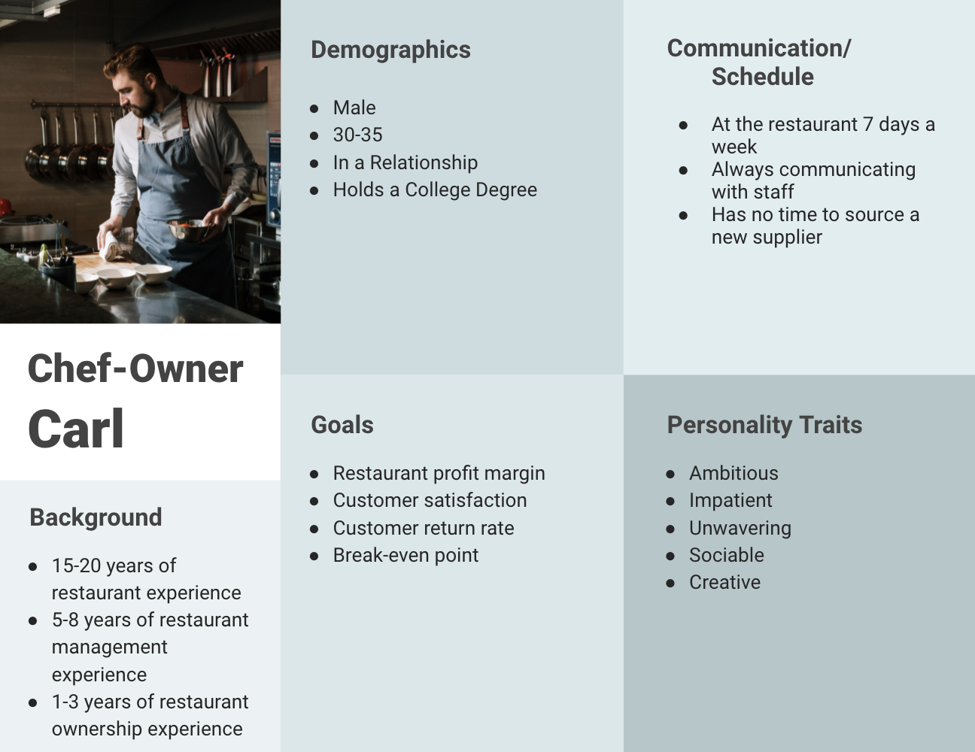

### Location Analysis

Our location in Smithfield, Rhode Island gives us easy access to all of our most common destinations. We’re less than 20 minutes to downtown Providence and to the borders of Massachusetts and Connecticut.

### Competitor Analysis

|  | **Comparative Strength(s)** | **Comparative Weakness(es)** | **Counter-****point(s)** |
| --- | --- | --- | --- |
| **National Food** | PFS has a hyper -focus on Rhode Island and an emphasis on local. | NF has much lower prices due to national operations. | You’re paying for fresher, better food from your own community. |
| **USA Meat Providers** | PFS offers more than just meat, making ordering easier and from one vendor. | USA’s meats are considered the best quality in the nation. | PFS supports local and sustainably-  sourced meats that USA doesn’t. |
| **New England Provisions** | Our provisions are fresher and of higher quality than NEP. | NEP has a wider reach, thus more capital and influence, and low prices. | Again, our hyper-focus is on Rhode Island and community. |

# 

# Marketing Plan

### Positioning Strategy

Rhode Island is the forgotten state. By positioning ourselves as the champion of Rhode Island, its inhabitants, and its entire food scene, we’ll be synonymous with restaurants in the area.

As a full-service food provider, we’ll take the headache out of having to work with multiple providers and offer immediate, fresh, and locally-sourced products for our clients. That way they can focus on creating a great guest experience without having to worry about when or if their next shipment will arrive.

### Acquisition Channels

Our main acquisition channels are as follows:

* **Event Marketing:** We will attend local restaurant events and conferences to promote our provisions in Rhode Island and surrounding states.
* **Paid Marketing**: We will invest in SEM on Google to target keywords pertaining to food provisions, geo-focused on Rhode Island and surrounding states.
* **Website Marketing:** We will optimize our website for relevant keywords and perfect our conversion path to ensure those who come on our website stay on our website.

### Tools and Technology

To manage our digital presence, we will employ the following tech tools:

* [HubSpot CMS](https://www.hubspot.com/products/cms): Will manage our website with HubSpot and publish all of our content through it.
* [Marketing Automation Software](https://www.hubspot.com/products/marketing/marketing-automation): To engage our leads in workflows, we will use automation tools.
* [HubSpot CRM](https://www.hubspot.com/products/crm): We’ll use HubSpot CRM to track and maintain relationships with our contacts.

# Sales Plan

### Sales Methodology

Our strategy will be a part inbound, part outbound strategy. Inbound will be enacted using the acquisition channels listed above in the Marketing Plan Section.

For our outbound work, we will work on account-based sales. We want to build relationships with Rhode Island’s most prominent restaurants, and to do that, we need to take an active role in forming these connections.

### Sales Organization Structure

We have two in-house BDRs to work out inbound and outbound funnel from the office. We also have three outbound sales reps to actively form connections and respond to in-person inquiries.

The team is headed up by our VP of Sales, who reports to our CRO.

### Tools and Technology

We will utilize [HubSpot Sales Software](https://www.hubspot.com/products/sales) to manage our prospects’ sales cycle and information. This software also builds our sales reports, tracks revenue, and analyzes our goal analysis.

# Legal Notes

### 

### Legal Structure

Providence Food Provides is an LLC and a fully licensed business.

### Legal Considerations

Our biggest considerations come from the FDA. We work closely with local professionals to ensure our sourcing, storage, and delivery is safe and compliant with these restrictions. We’re also fully compliant with restrictions for states in all of New England + New York to cover our bases as we expand.

# Financial Considerations

### 

### Startup Costs

| Description | Cost |
| --- | --- |
| Marketing | $50,000 |
| Real Estate and Storage | $400,000 |
| Inventory | $20,000 |
| Delivery Trucks | $80,000 |
| Hiring Costs | $200,000 |
| **Total** | $750,000 |

### Sales Forecasts

We’re projecting **$2.5 million** in annual revenue by the end of the year, assuming a 4% month-over-month growth attainment.

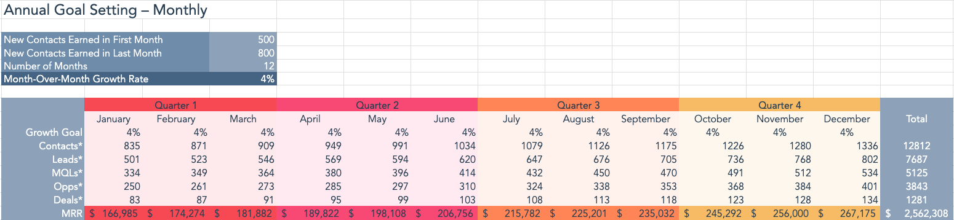

### Funding Requirements

To help us fuel our growth, we’re seeking $1,000,000 to supplement our $250,000 of self-invested funds.

# 

| **Grow Your Business  With HubSpot CRM**  HubSpot’s free CRM software helps scaling businesses connect with their contacts and grow their customer base. | |  | |
| --- | --- | --- | --- |
|  | [**Get Free CRM Software**](https://www.hubspot.com/products/crm) | |  |
|  | | | |